Game Design Document

Fill up the Following document

1. Write the title of your project.

Mysterious land

1. What is the goal of the game?

The goal of the game is that we have to work with our mind and complete the levels

1. Write a brief story of your game?

There are two characters they have to collect the points when they would get 10 points then a gate would open and they have to go through that to another level there would be 3 level the player who have the most wins would win the game.

1. Which are the playing characters of this game?

* Playing characters are the ones which respond to the user based on the input from the user
* Cars, monkeys, dinos, wizards etc, are the playing characters in the game.

|  |  |  |
| --- | --- | --- |
| Number | Character Name | What can this character do? |
| 1 | flash | It can move through arrow keys and shoot bullets to destroy dinos . |
| 2 | crusher | It can move through ‘w’ ‘a’ ‘d; keys and shoot bullets to destroy dinos . |
| 3 |  |  |
| 4 |  |  |
| 5 |  |  |
| 6 |  |  |
| 7 |  |  |
| 8 |  |  |

1. Which are the Non Playing Characters of this game?

* Non Playing characters are the ones which don't have an action or a behaviour when the user interacts with the game.
* Hurdles, stones, bananas, coins, etc are non playing characters in the game.

|  |  |  |
| --- | --- | --- |
| Number | Character Name | What can this character do? |
| 1 | Dinos | They are the obstacles for the playing characters and make the game diffiult |
| 2 |  |  |
| 3 |  |  |
| 4 |  |  |
| 5 |  |  |
| 6 |  |  |
| 7 |  |  |
| 8 |  |  |

Draw your imagination of this game. What does this game look like?

* Draw the game either on your computer or on paper,
* Add images of scenes of the game to show each of the playing and non-playing characters at least once.

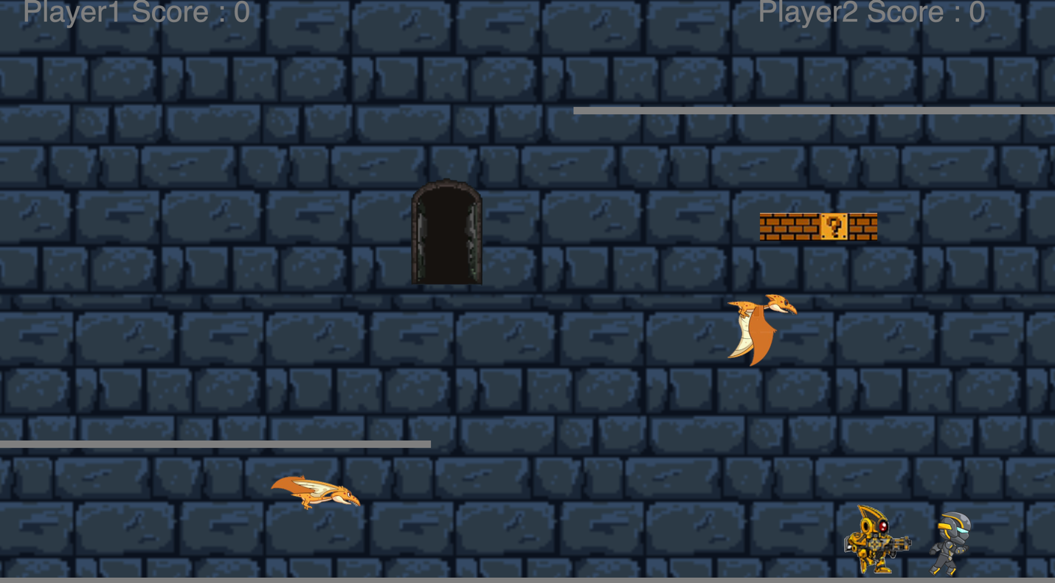

How do you plan to make your game engaging?

By adding animations and a tough competition